**Install MongoDB**

Start an interactive shell in a container with: sudo docker run -i -t ubuntu /bin/bash

root@0087b25c0b3c:/# apt-key adv --keyserver hkp://keyserver.ubuntu.com:80 --recv 7F0CEB10

root@0087b25c0b3c:/# echo 'deb http://downloads-distro.mongodb.org/repo/ubuntu-upstart dist 10gen' | tee /etc/apt/sources.list.d/10gen.list

root@0087b25c0b3c:/# apt-get update

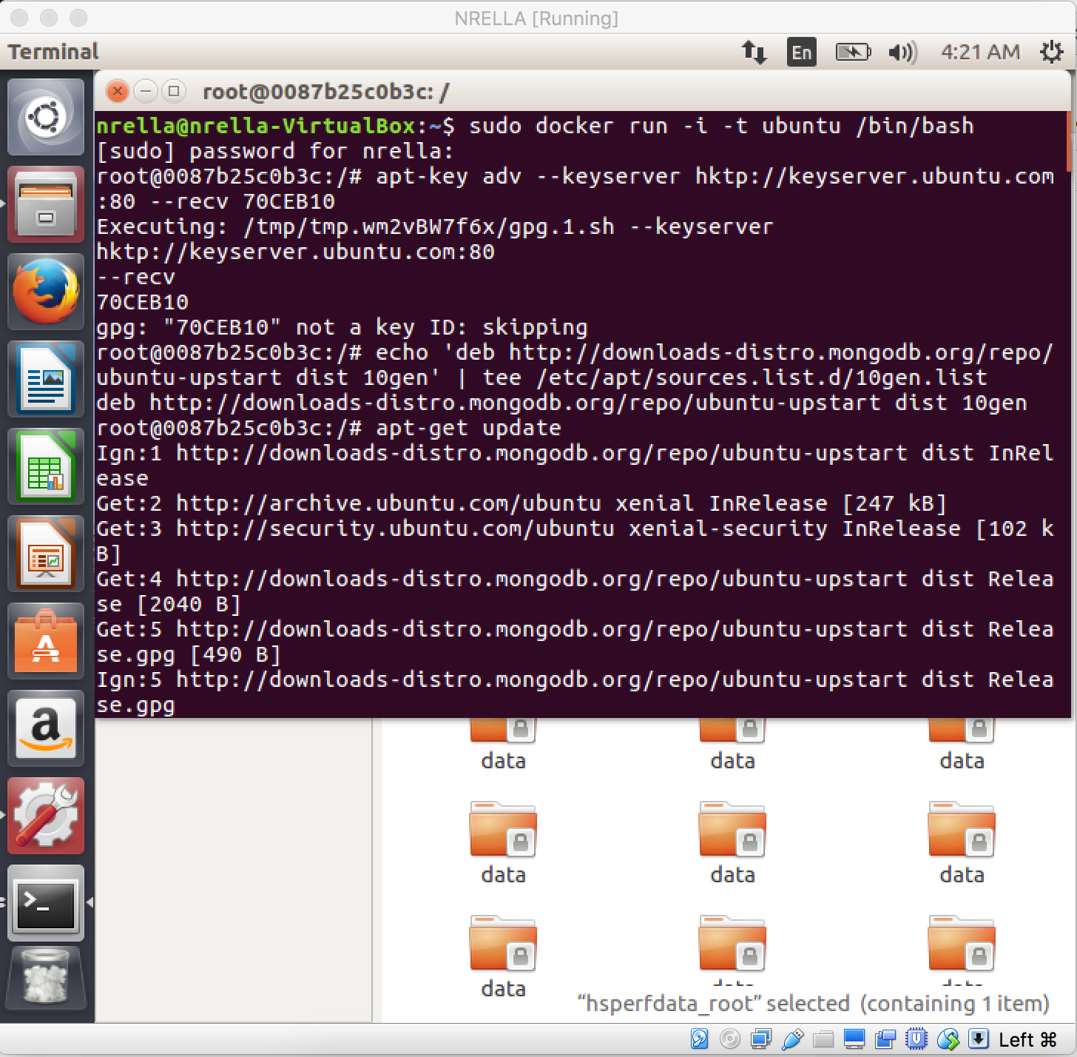

root@0087b25c0b3c:/# dpkg-divert --local --rename --add /sbin/initctl

root@0087b25c0b3c:/# ln -s /bin/true /sbin/initctl

root@0087b25c0b3c:/# apt-get install mongodb-10gen

root@0087b25c0b3c:/# mkdir -p /data/db

root@0087b25c0b3c:/# mongod

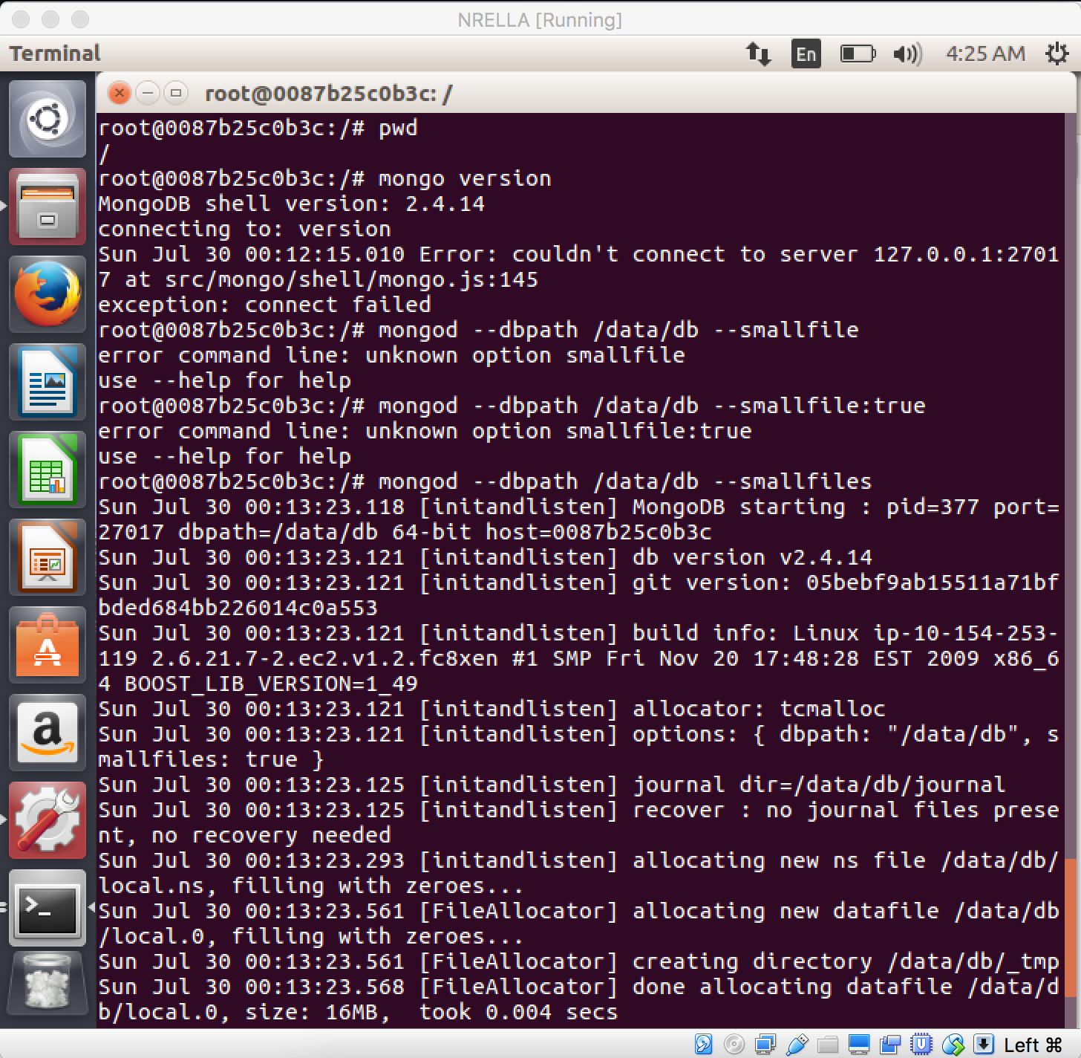

In another terminal;  
  
MongoDB starts succesfully in the container. Now we need to commit the container, to save the state and push to the docker index.  
sudo docker commit 0087b25c0b3c nrella/mongodb  
dock@saas:~$ sudo docker commit 0087b25c0b3c nrella/mongodb

dock@saas:~$ sudo docker login

Username: nrella

Password:

Login Succeeded

dock@saas:~$ sudo docker push nrella/mongodb

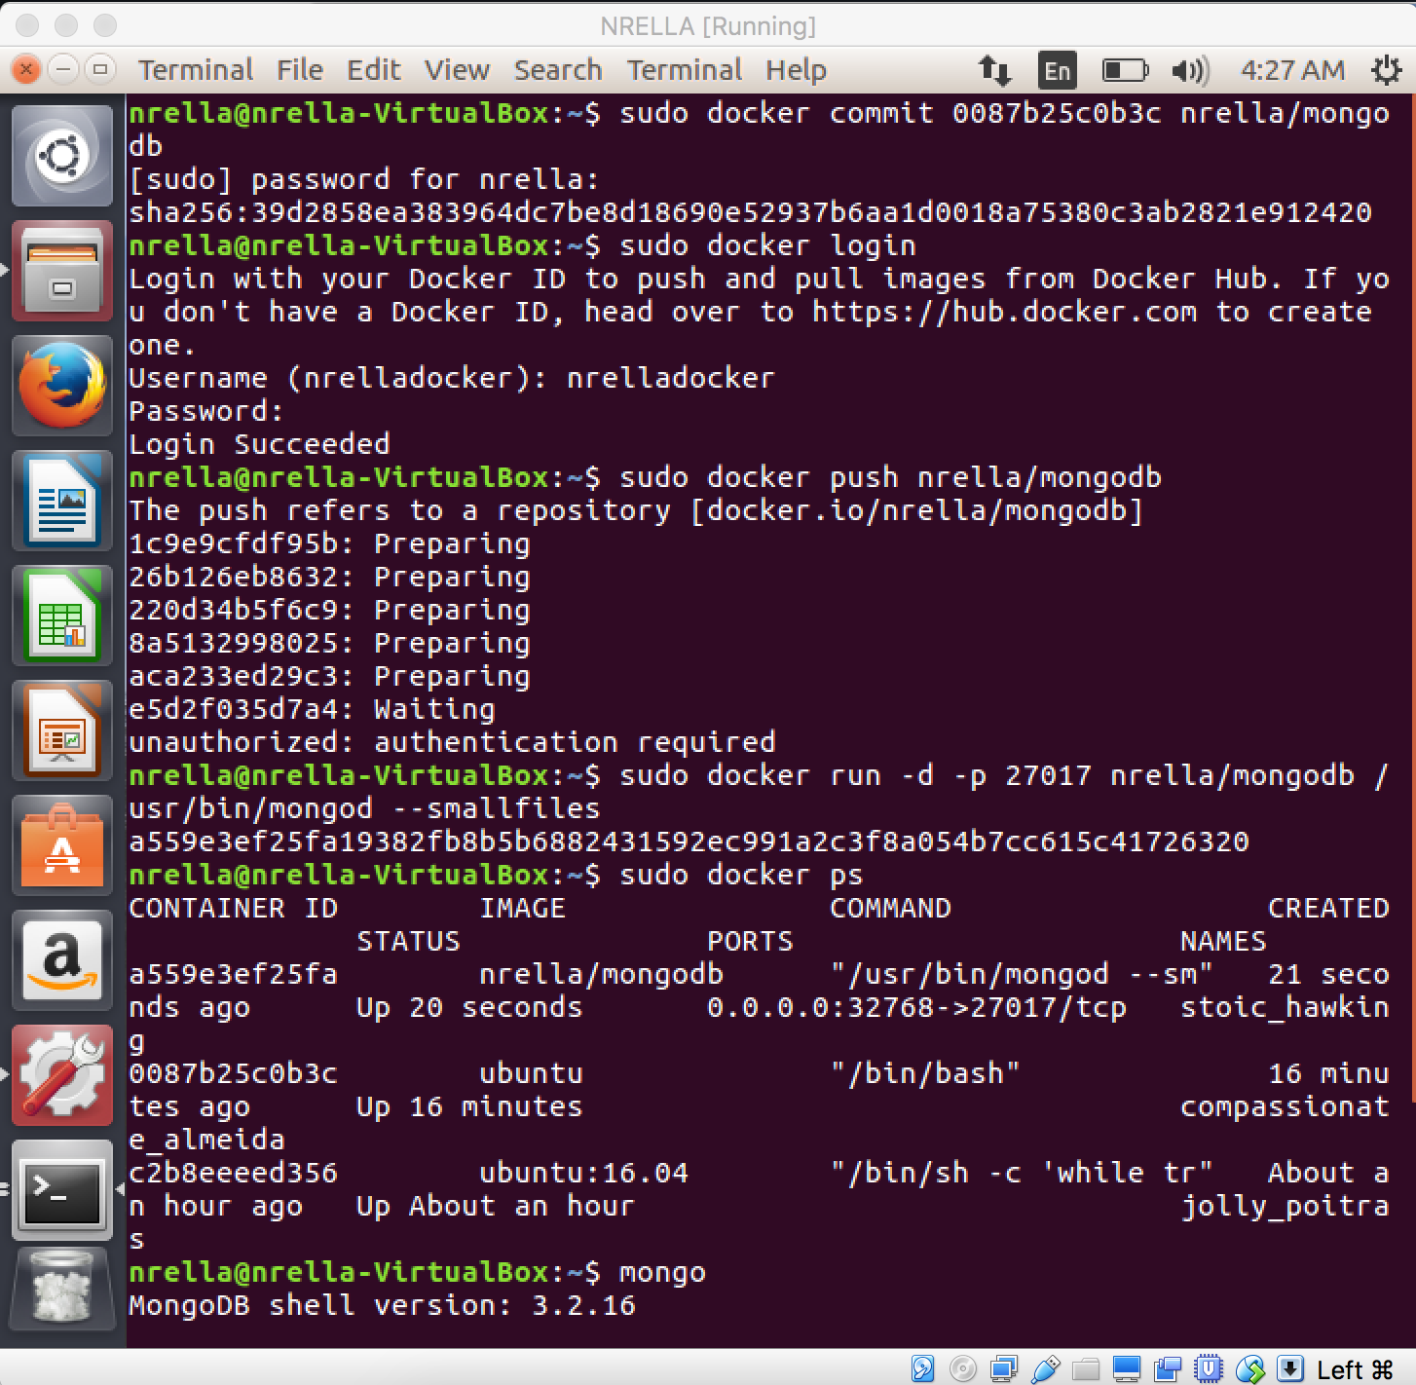

Insert a record on to mongo DB.

To test it and then check the docker is holding mongdb.

